**Use Cases - Orders Tab**

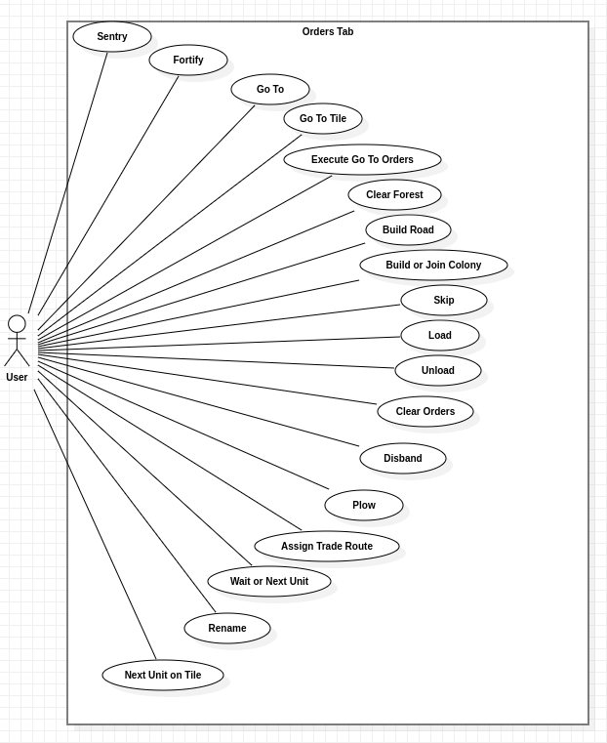

**Name:** Sentry

**Description:** The user commands the unit to enter “sentry” mode, waiting for something to happen to it.

**Primary Actor:** User

–

**Name:** Fortify

**Description:** The user directs the unit to establish a defensive stance, reinforcing its position to repel potential threats.

**Primary Actor:** User

–

**Name:** Go To

**Description:** The user instructs the unit to move to a specified destination.

**Primary Actor:** User

–

**Name:** Go To Tile

**Description:** The user commands the unit to navigate to a particular tile on the map.

**Primary Actor:** User

–

**Name:** Execute Go To Orders

**Description:** The user prompts the unit to execute a series of movement commands, following the designated path.

**Primary Actor:** User

–

**Name:** Clear Forest

**Description:** The user commands the unit to clear a forested area.

**Primary Actor:** User

–

**Name:** Build Road

**Description:** The user directs the unit to construct a road

**Primary Actor:** User

–

**Name:** Build or Join Colony

**Description:** The user commands the unit to engage in the establishment or reinforcement of a colony.

**Primary Actor:** User

–

**Name:** Skip

**Description:** The user instructs the unit to skip its turn

**Primary Actor:** User

–

**Name:** Load

**Description:** The user directs the unit to load items or individuals (in the case of ships, for example) onto itself

**Primary Actor:** User

–

**Name:** Unload

**Description:** The user commands the unit to offload its cargo.

**Primary Actor:** User

–

**Name:** Clear Orders

**Description:** The user directs the unit to clear all pending orders.

**Primary Actor:** User

–

**Name:** Disband

**Description:** The user orders the unit to disband.

**Primary Actor:** User

–

**Name:** Plow

**Description:** The user instructs the unit to prepare the land for cultivation.

**Primary Actor:** User

–

**Name:** Assign Trade Route

**Description:** The user directs the unit to establish or modify a trade route.

**Primary Actor:** User

–

**Name:** Wait or Next Unit

**Description:** The user commands the unit to wait for its next turn or for the next unit’s action.

**Primary Actor:** User

–

**Name:** Rename

**Description:** The user changes the name of the unit.

**Primary Actor:** User

–

**Name:** Next Unit on Tile

**Description:** The user directs the unit to focus on the next unit present on the same tile.

**Primary Actor:** User